**Calculator Documentation**

**Introduction**

Welcome to the Calculator Application Documentation! This comprehensive guide provides detailed insights into the calculator project, offering a deeper understanding of its core functionalities, technical aspects, and potential future improvements.

The calculator application serves as an intuitive and user-friendly tool for performing basic mathematical operations. Through the application of Object-Oriented Programming (OOP) principles, graphical user interface (GUI) design, and event-driven programming, the calculator ensures a seamless user experience.

**Key Functionalities**

**Core Functionalities**

**Basic Arithmetic Operations**: Addition, subtraction, multiplication, and division.

**Decimal Point**: Capability to input decimal numbers.

**Clear and Delete**: Options to clear the entire input or delete the last character.

**Negative Numbers**: Ability to change the sign of the current number.

**Error Handling**: Graceful handling of invalid inputs.

**User Interactions and Expected Outcomes**

* **Button Clicks**: Clicking numeric and operation buttons updates the input display.
* **Equals (=) Button**: Computes and displays the result of the entered expression.
* **Clear (Clr) Button**: Clears the input field.
* **Delete (Del) Button**: Removes the last entered character.
* **Negative (-) Button**: Changes the sign of the current input.

**Methodology / Technical Part**

**-Object-Oriented Design**

**Abstraction**

Abstraction is implemented in the **CalculatorButton** class, representing abstracted calculator buttons:

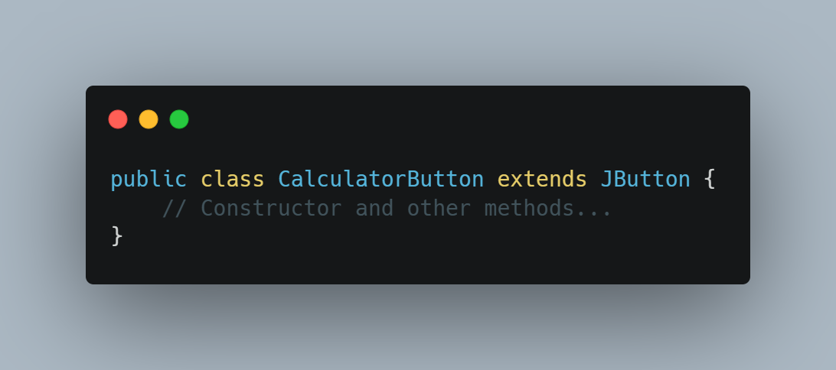

**Encapsulation**

Encapsulation is applied with private variables encapsulating the internal state within the **CalculatorNew** class:

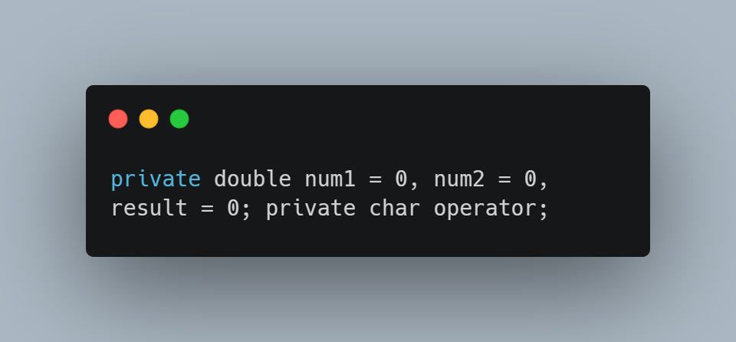

**Inheritance**

Inheritance is demonstrated through the extension of **JButton** in the **CalculatorButton** class:

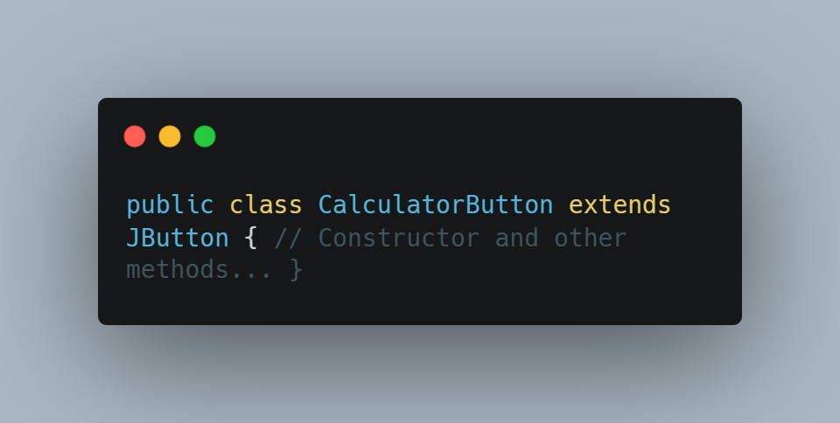

**Polymorphism**

Polymorphism is showcased in the **CalculatorNew** class, implementing the **ActionListener** interface:

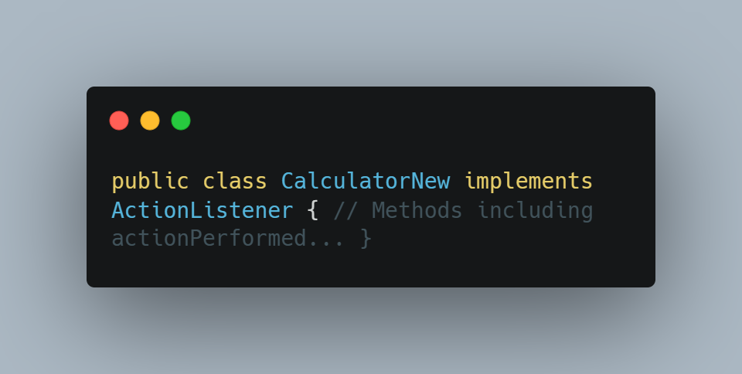

**GUI and Event-Driven Programming**

For GUI and event-driven programming, the Swing library is used for GUI components, and event listeners capture and respond to user interactions:

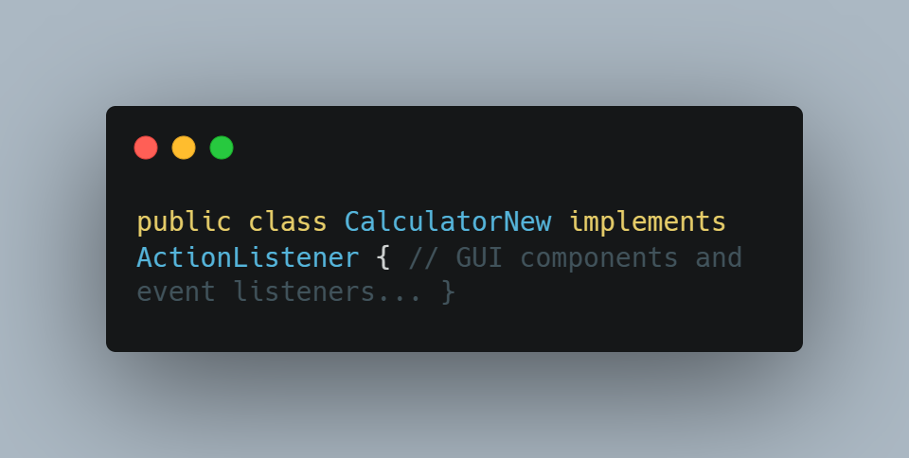

**Technical Aspects**

The technical aspects include font customization, dynamic button creation, and exception handling:

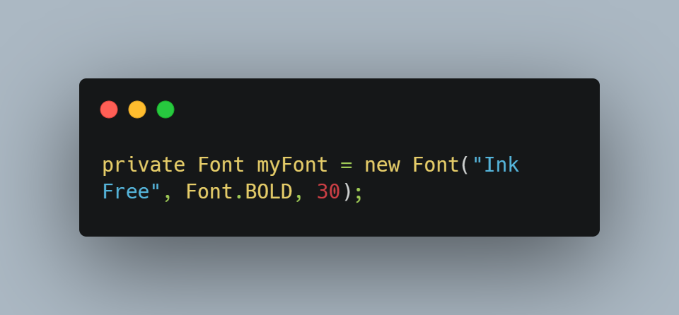

**Summary**

The Calculator Application successfully integrates Object-Oriented Programming (OOP) principles, GUI design, and event-driven programming to deliver a functional and user-friendly tool for basic mathematical operations. Core functionalities include basic arithmetic operations, decimal point input, clear/delete options, and error handling.

**Future Enhancements**

Looking ahead, our goal is for the calculator to have a use for much more difficult mathematical operations, including use in a scientific calculator and that may not be the only use developed